Gabe Quinones
2/7/2026
Books REST API
Google Cloud Function URL: https://us-central1-sp26-cit50100-scratch-gquinon.cloudfunctions.net/books-api

Purdue GitHub URL: https://github.itap.purdue.edu/gcquinon/books-api

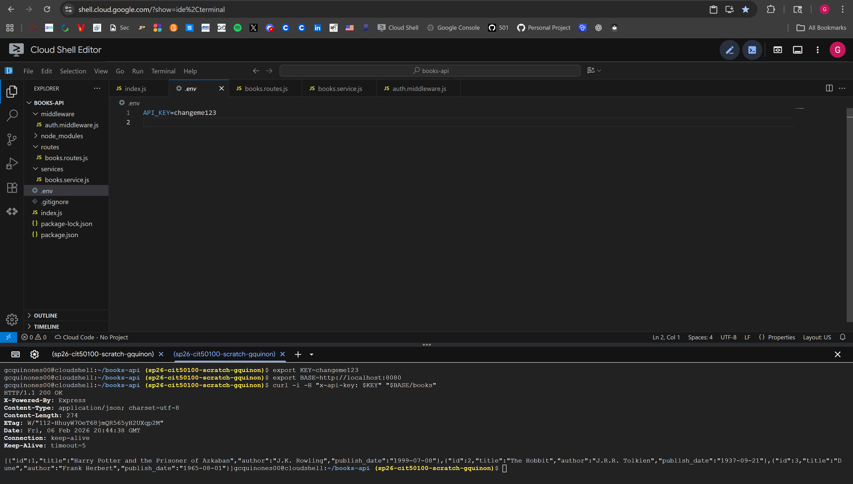
Result for getting all books.
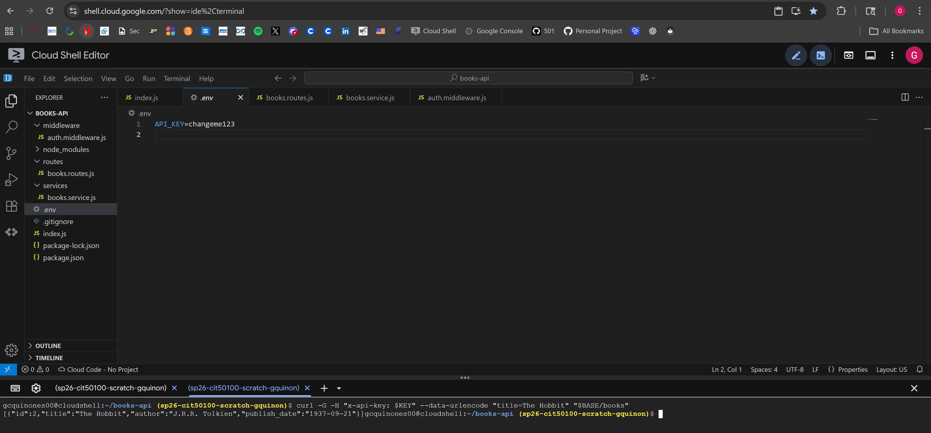
Result for getting all books with a single filter.
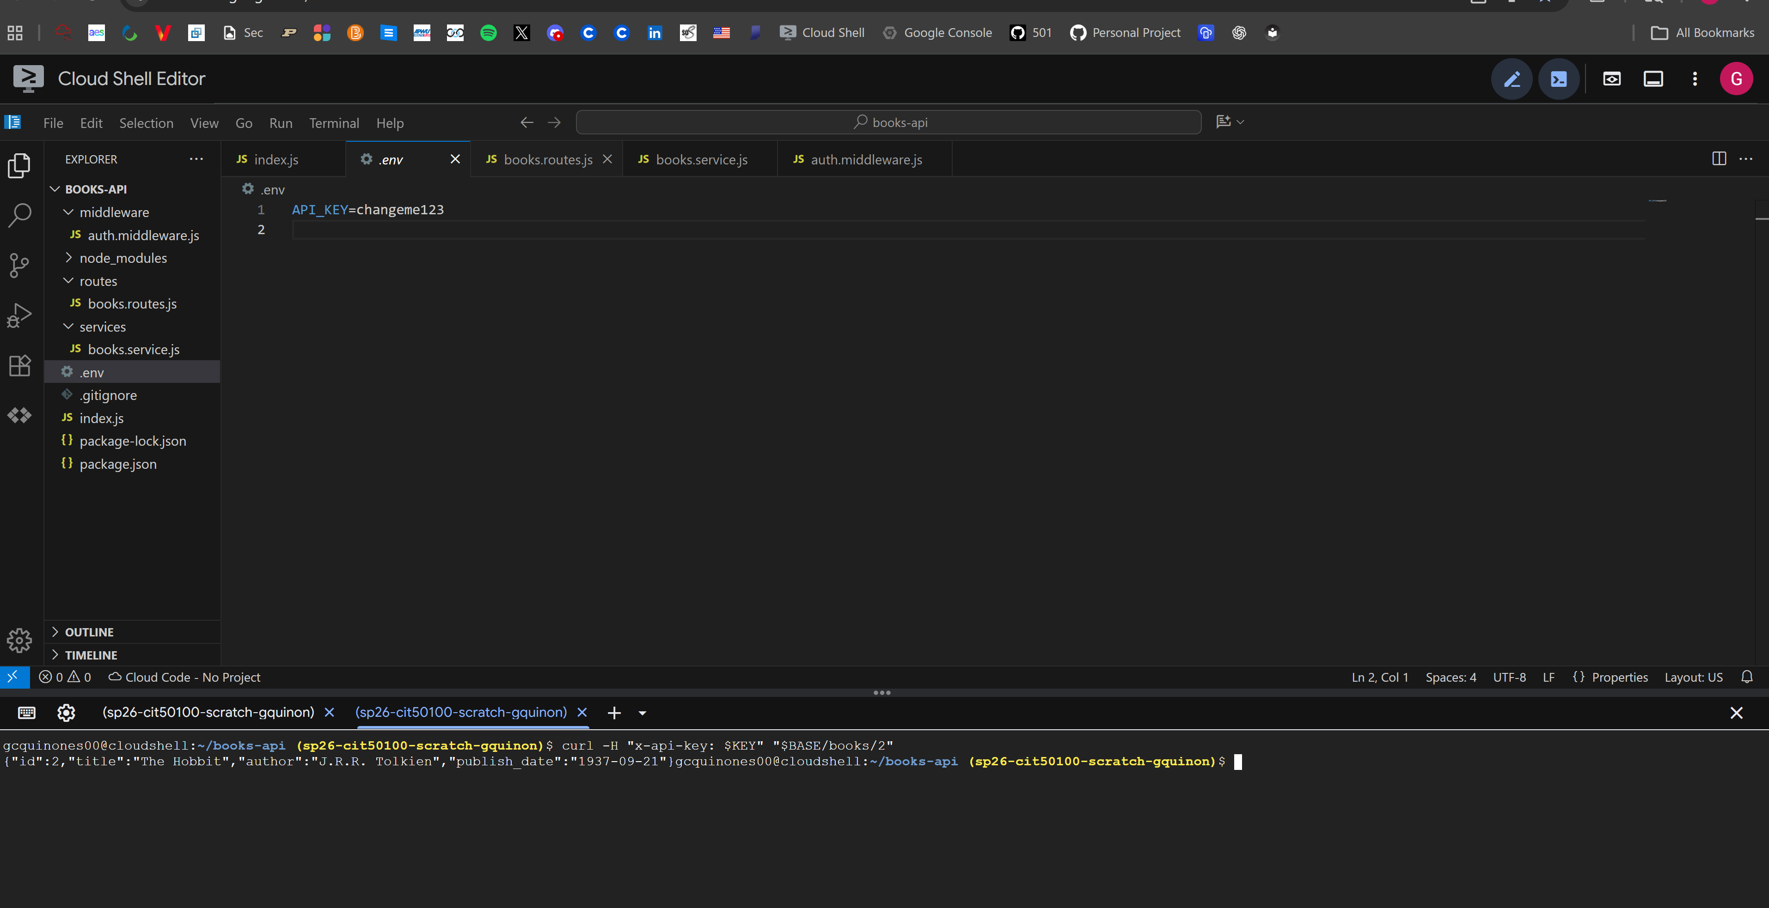
Result for getting a book by ID successfully.
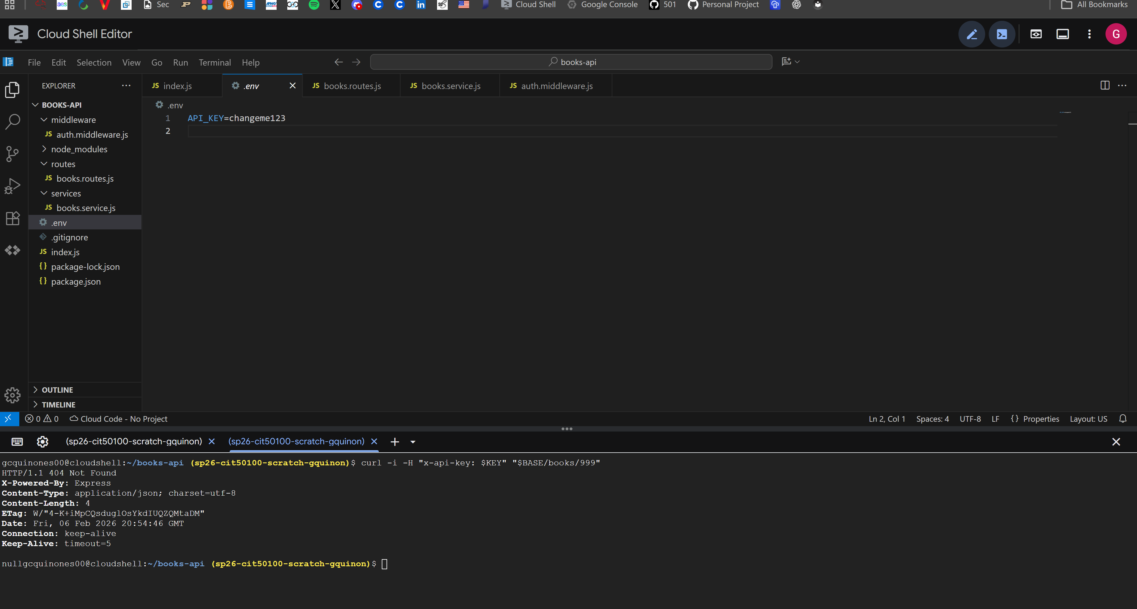
Result for getting a non-existent book with a valid ID.
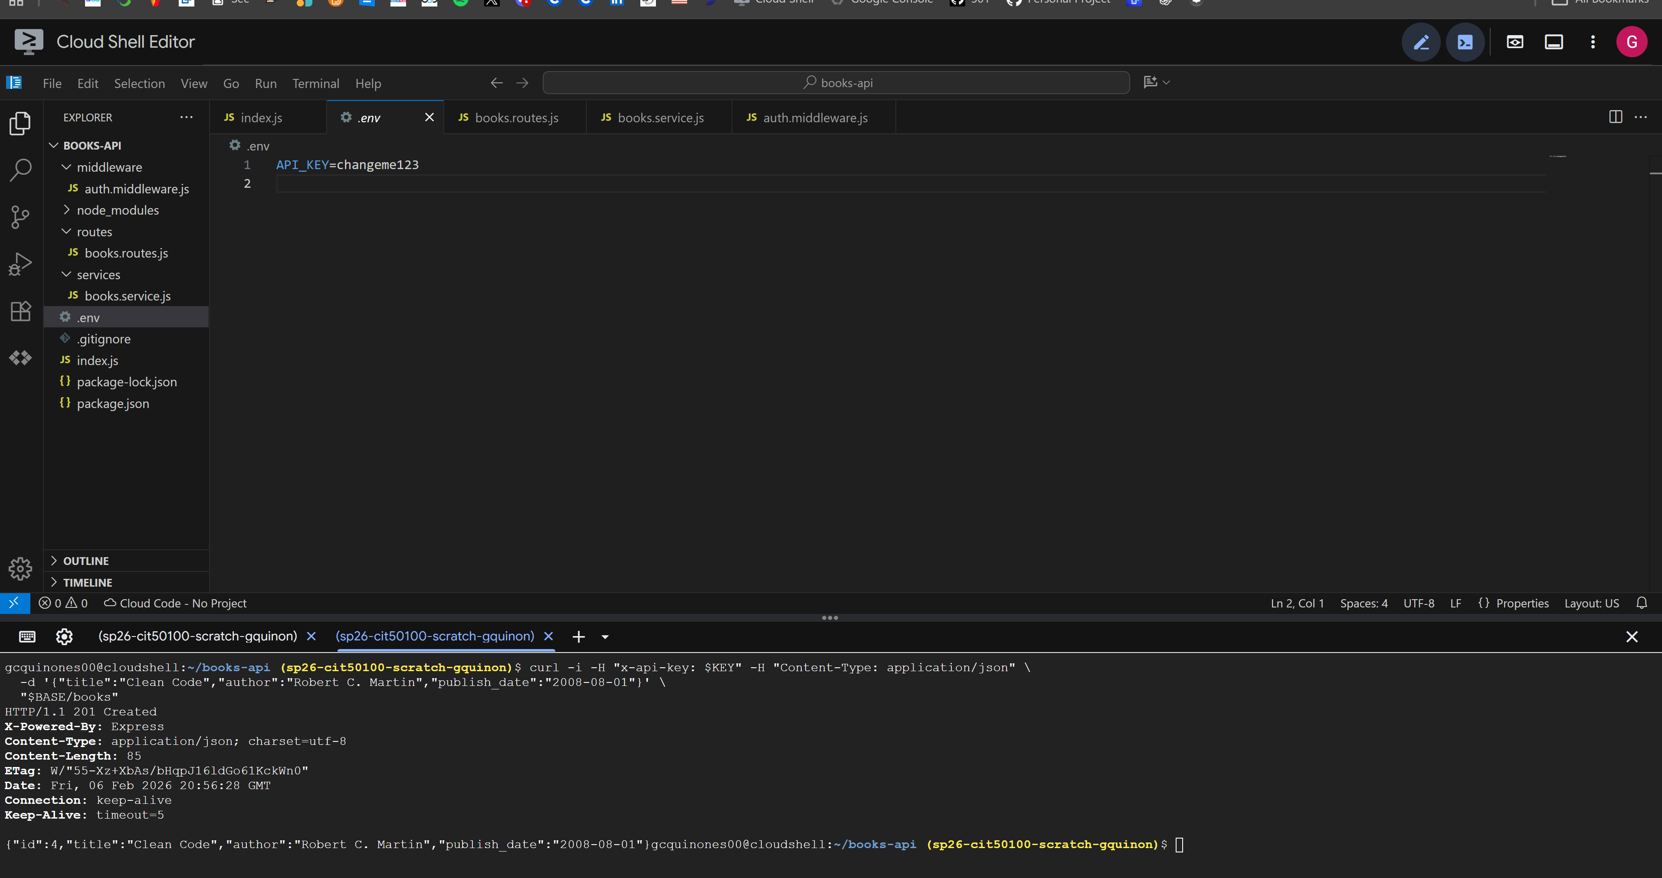
Result for creating a book successfully.
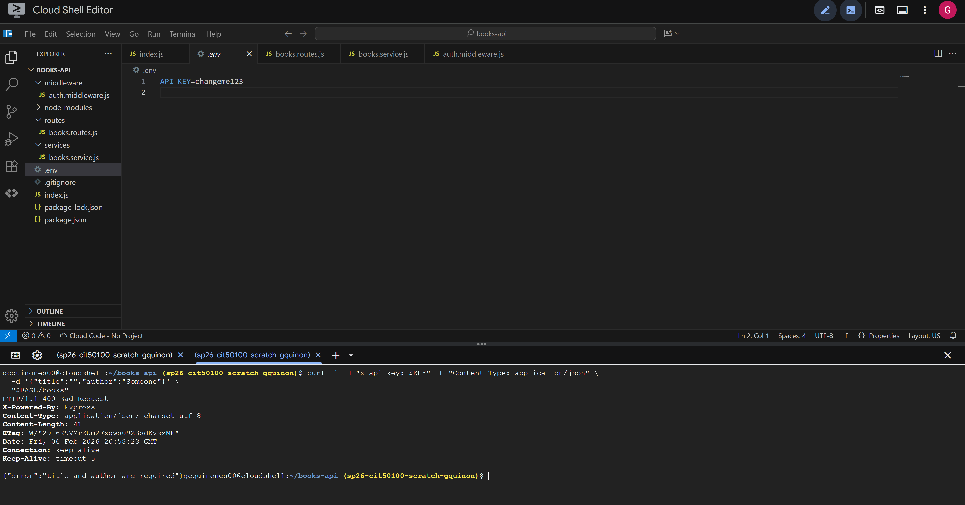
Result for creating a book with error (missing or bad data).
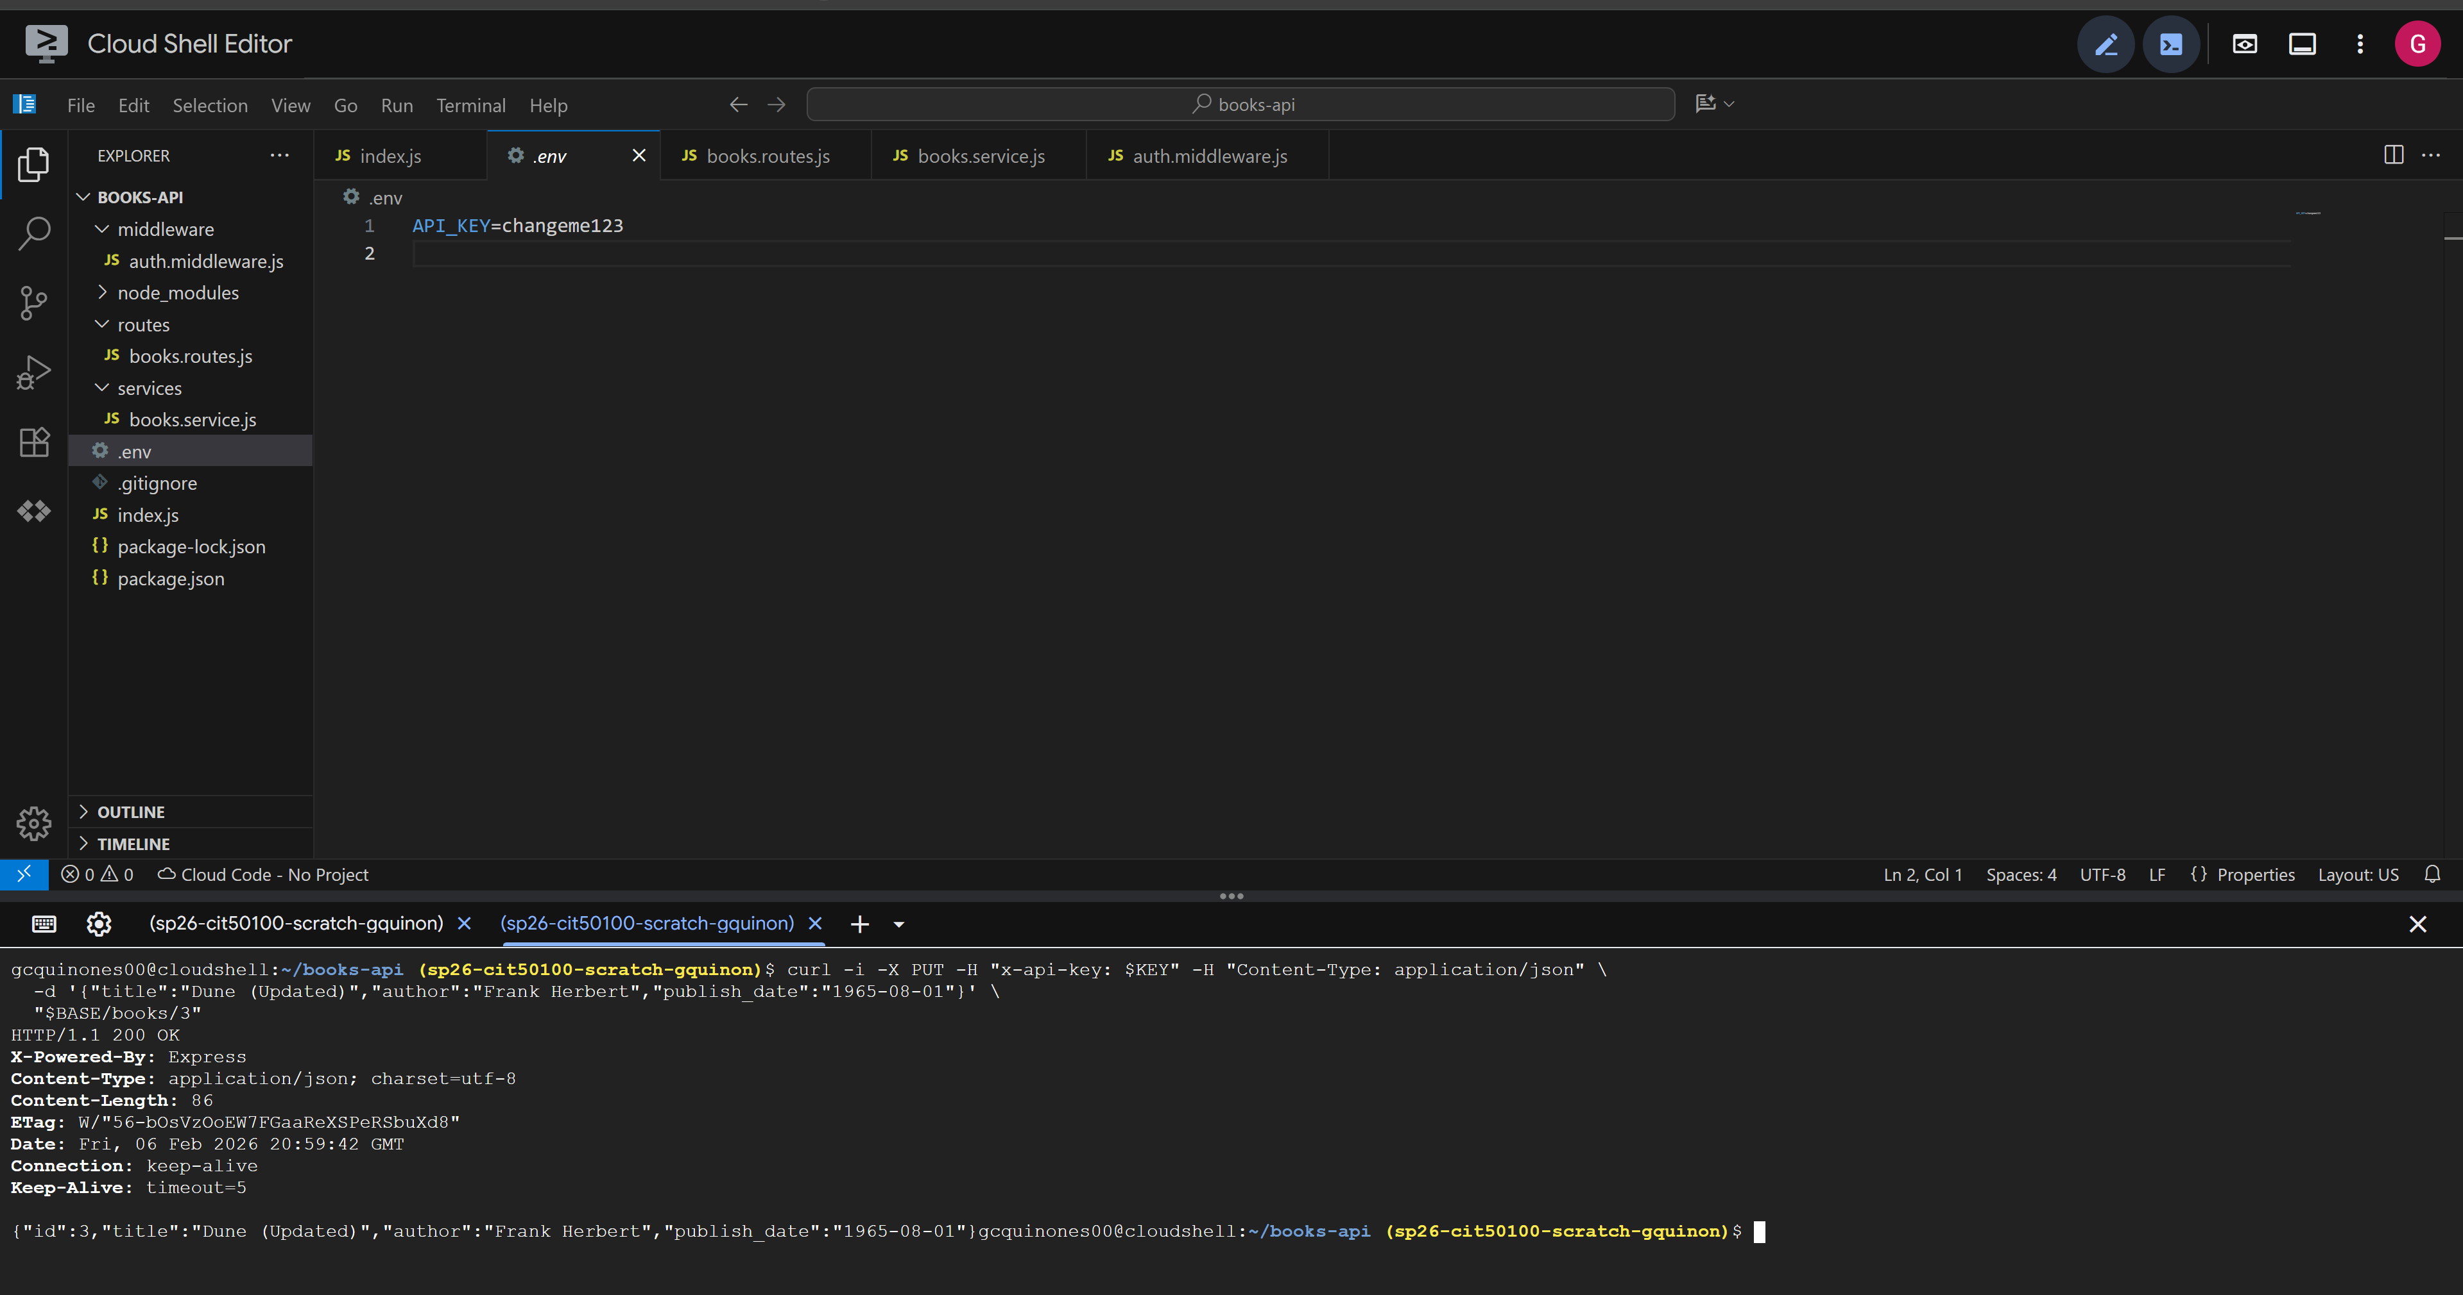
Result for updating a book successfully.
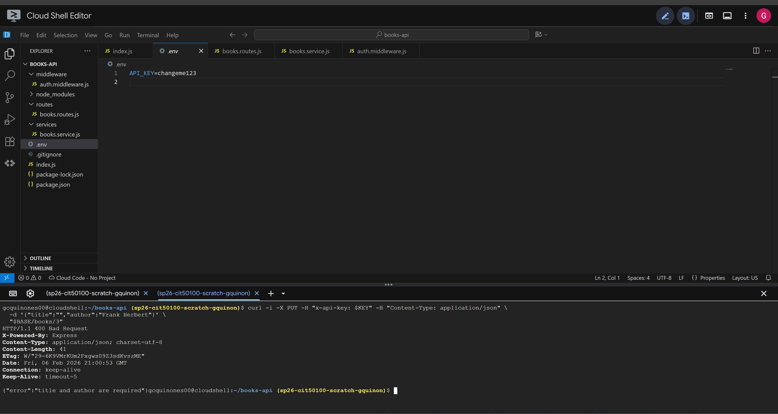
Result for updating a book with error (missing or bad data).
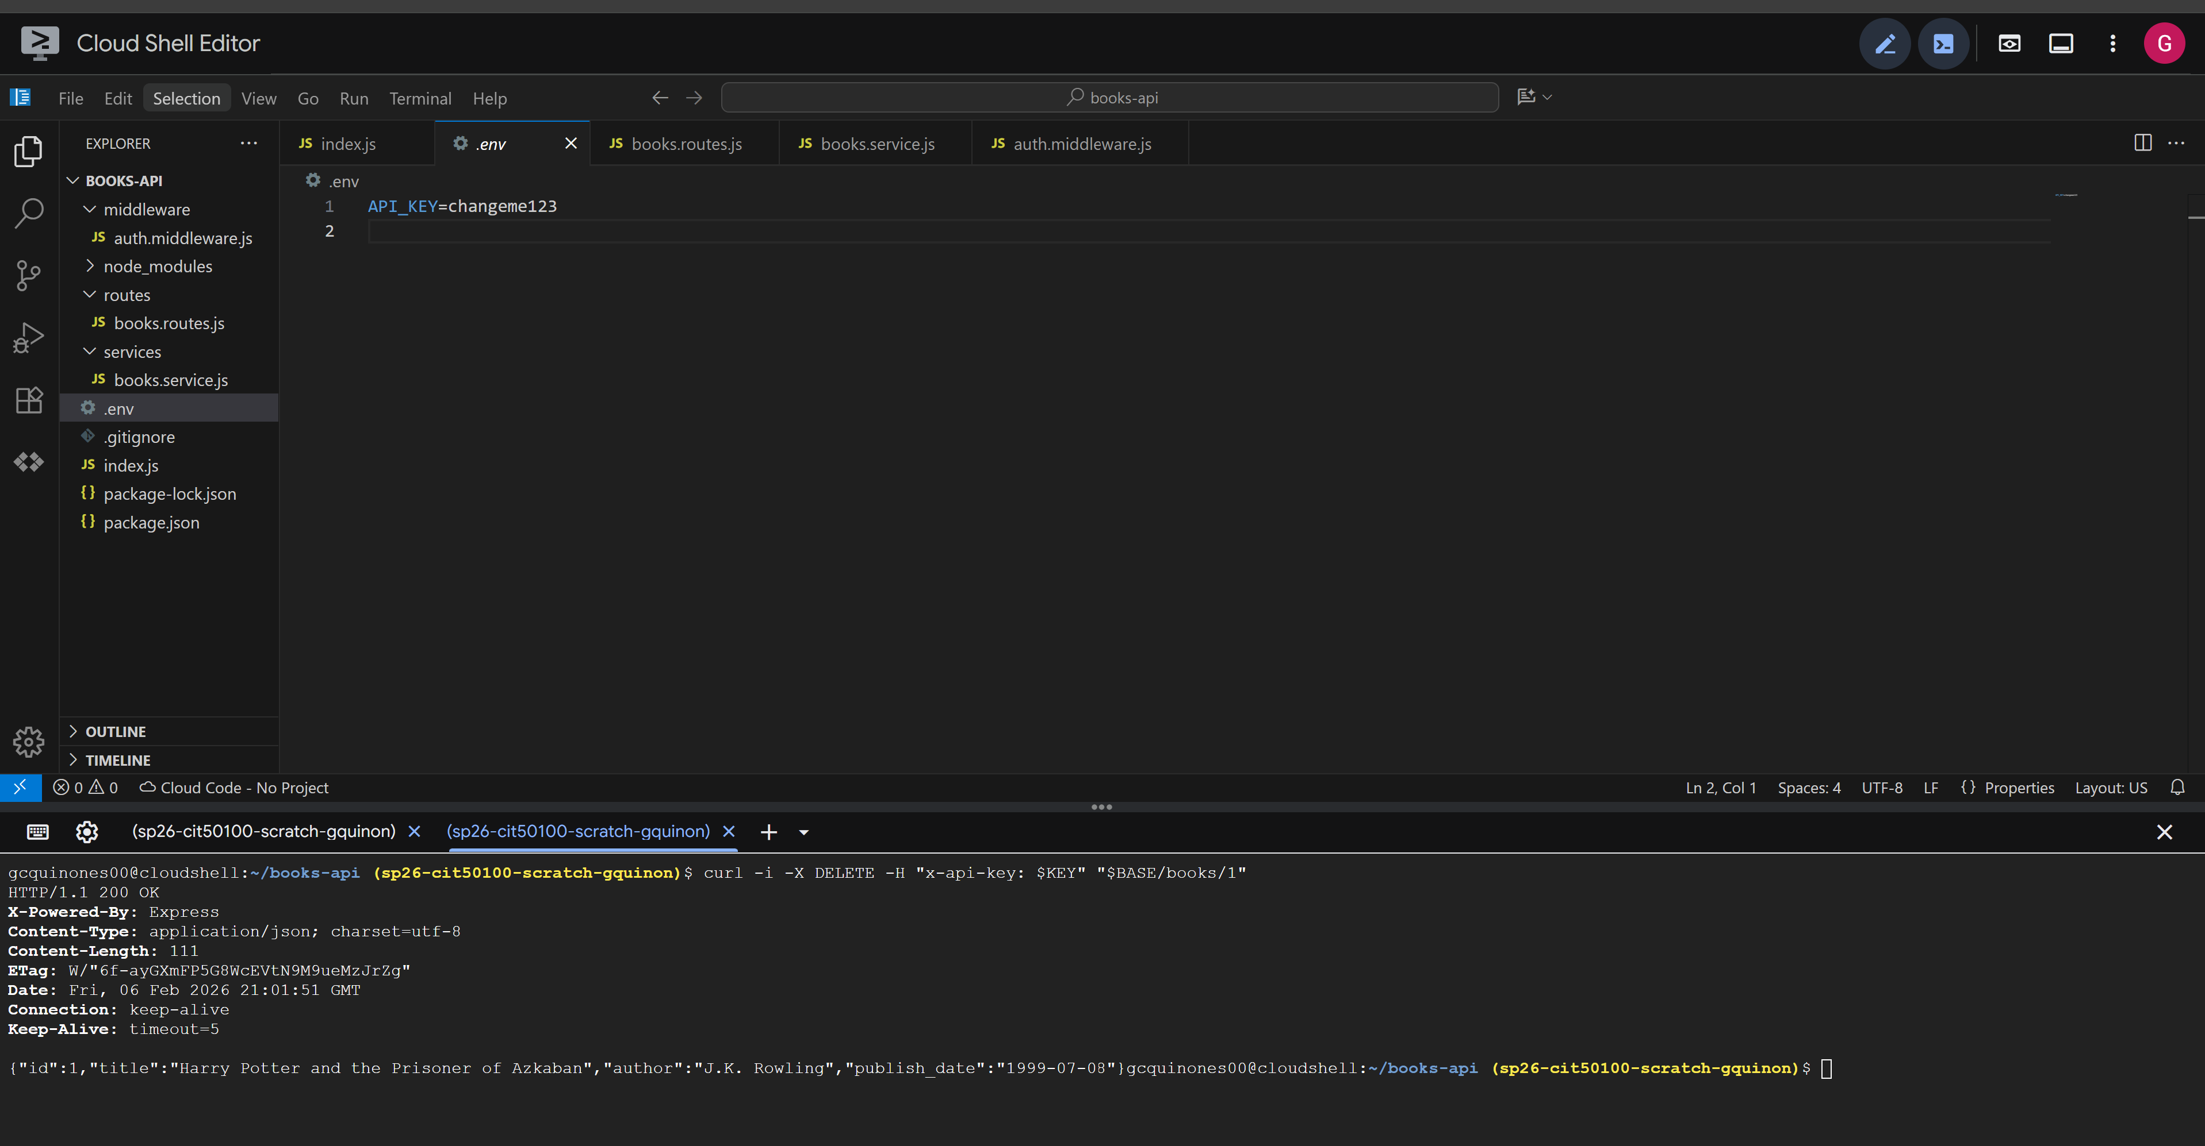
Result for deleting a book successfully.
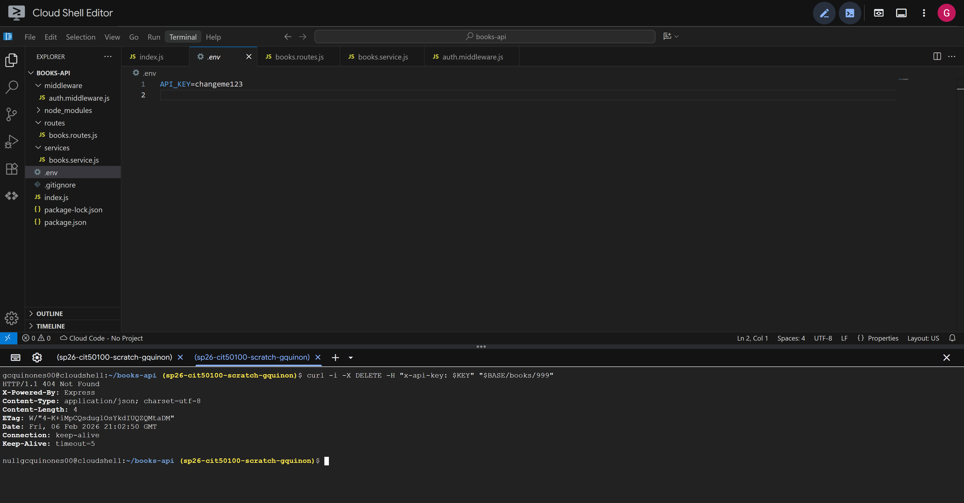
Result for deleting a non-existent book but valid ID.
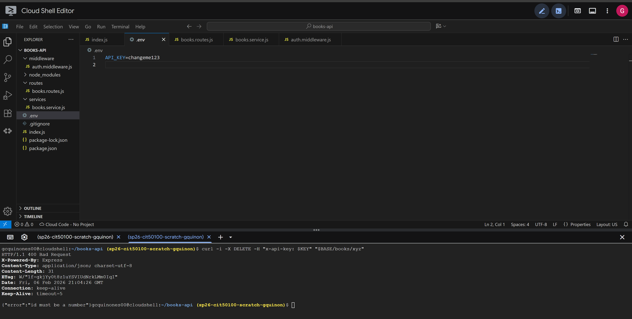
Result for deleting a book with an invalid ID.

